
u|Lg ;f];fO6L klAns :s'n
/Tggu/–&, ;f}/fxf lrtjg
t];|f] q}dfl;s परीक्षा—@)*@
sIff M– g;{/L समय - @ 3+= k"0ff{ÍM–%) ljifoM–g]kfnL df}=
!= tkfO{sf] gfd s] xf] < %
@= tkfO{ slt jif{sf] x'g' eof] < %
#= tkfO{ slt sIffdf k9\g'x'G5 < %
$= tkfO{sf] ljBfnosf] gfd s] xf] < %
%= tkfO{nfO{ dgkg]{ t/sf/Lsf] gfd s] xf] < %
^= xfd|f] /fli6«o km"nsf] gfd s] xf] < %
&= tnsf] cIf/x? eGg’xf];\ . !)
/ n j z if ; x If q 1
*= tnsf] lrqx?sf] gfd eGg'xf];\ . %
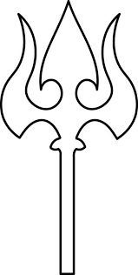




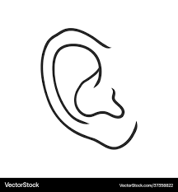


;dfKt

